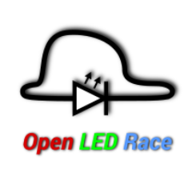Open LED Race

Carrera track on a NeoPixel strip

Winner is the one who can press the button the fastest, or the one who moves the weights the hardest.

The start count down begins when a button is pressed or a big movement is made with a weight.

There are 5 laps to go.